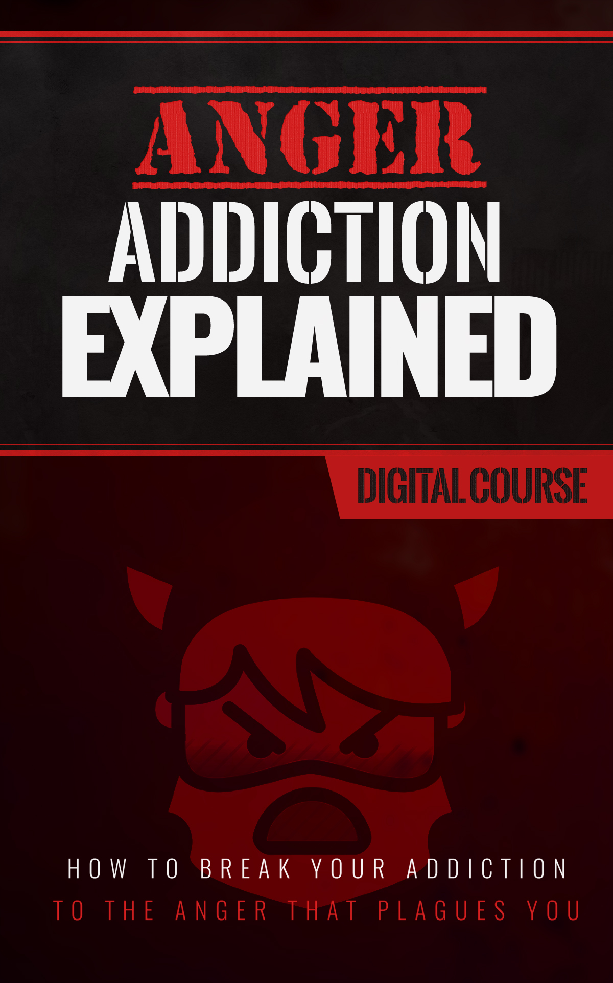
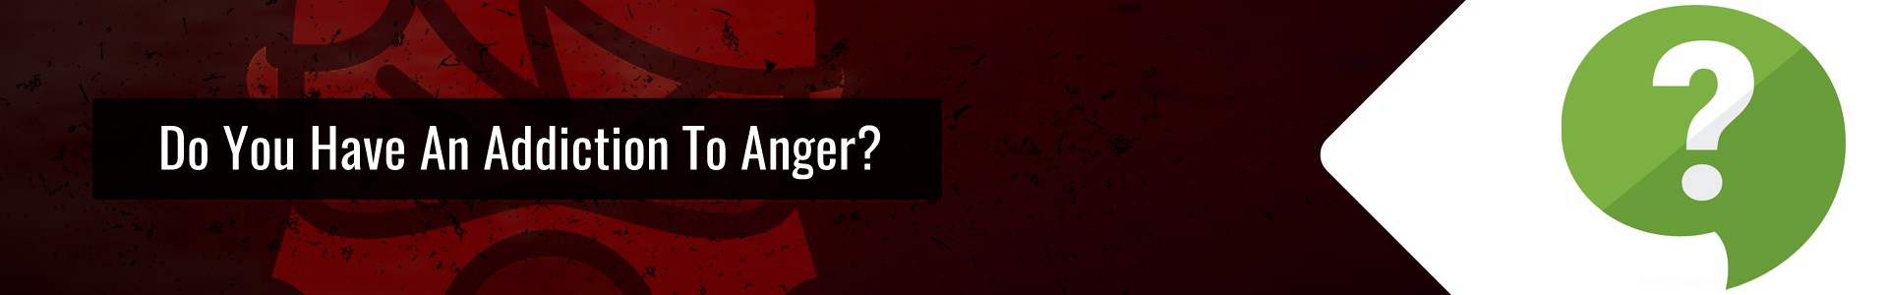
Addiction, whether it's alcohol, tobacco, or any other sort, is a disruptive force in many lives. Nearly everyone is addicted to something. Human beings are creatures of habit, and habits are everywhere, some good, but most of the ones we focus on are detrimental.

Actions become addiction for one reason: repetition.

Any time you repeat the same thing over and over, on any kind of regular cycle, it becomes habit. Take a morning cup of coffee, for instance. You wake up tired one day, and decide to have some coffee. It helps to wake you up and motivate you, so the next day you try it again. You tell yourself that it's going to help you wake up and be more productive, so you keep doing it, even when you wake up full of energy, you get your coffee. At this point, morning coffee has become a habit.

Habits form through repetition, and they are the first step toward addiction. If that habit is something positive, like brushing your teeth or practicing an instrument, this is a good thing. If it's getting angry as soon as the day draws to a close, or any time things don't turn out the way you wish or expect, that's not. Of all the things you could become addicted to, anger is perhaps the worst. It's also one of the most misunderstood addictions, because we don't think of it as an addiction.

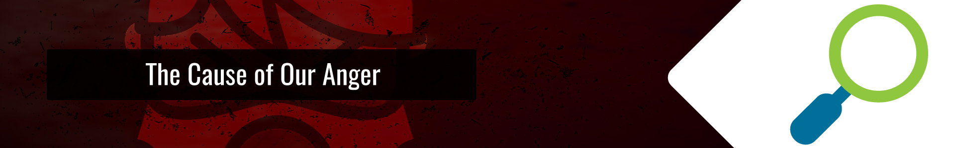
Anger is typically seen as a reflex. Therefore, the habit or addiction of being angry isn't as visible as that of smoking cigarettes, drinking coffee, or watching TV. It creeps up when your smoke break is interrupted, you run out of coffee, or the TV burns out before your favorite show. Because comes from a reactive trigger, we tend not to think of anger as an addiction. But it is.

Angry people, on the whole, will respond to most stressful situations with a negative response. Shouting, and irrational destruction of property, are symptoms of something that could be much deeper than “he or she made me angry.” Stressful situations are a part of life. They are what make life interesting. And avoiding them mentally by chemicals or reactions is the easiest trap for addiction to lay for us. Angry people react that way through repetition and conditioning. It becomes their default method for reaction when things go wrong. It's not the trigger, it's how they have conditioned themselves to respond. It's a way to release you from facing the problem.

We all respond to these crummy occurrences in different ways. Some people drink or use nicotine. Some people get mad and find something to break, or something to hit, or someone to target with a battery of cut-downs and humiliation, or worse. Some people respond by eating. These are all very different responses that stem from the same root cause. We are looking for a way to remove ourselves from the situation. But why?

When something out of our control happens to us, we feel helpless. We can't control the weather, when the radio station is going to have a power failure, when a manufacturer's defect is going to make itself known while driving, or how other people are going to treat us.

We don't like our plans being interrupted. When those interruptions are beyond our control, it triggers the response to close ourselves off and hide in whatever habit is going to make us feel a little better.

From cookies 'n cream, to a cigarette, to a stiff drink, to drugs, or to simply getting mad. We turn off the part of the world we can't control by focusing on something we can.

This is where addictions come from. If your withdraw was to paint or play guitar, it wouldn't seem negative, but it would serve the same purpose.


If your default place to go when life isn't agreeing with you is to get angry, then you have possibly the worst addiction you could hope for. Just like drugs or alcohol, anger has side effects. It also has lasting effects.

If you have an habit of resorting to anger, nobody in the house is safe. Just like any drug, anger is going to affect you for a prolonged period of time. It can't be turned off easily once the fire is burning. It both creates negativity and feeds on it. Even if you focus on inanimate objects, others can get in the way of flying debris that might result.

Anything perceived as negative is going to be fuel for the fire. An innocent comment from a child, that might be seen as funny in a normal state, can enrage a parent. At the very least, the child will get a scolding they will never forget, and at the worst…

Spousal abuse is almost etched in stone. Think about it. When you see the person you love hurting, your immediate inclination is to help. You want to comfort them and tell them it's going to be okay. You might crack a joke trying to coerce a smile. When your angry, those attempts to make you feel better can sound belittling, or even look like personal attacks. The response of course? Withdraw further, and get more angry, or at least prolong the rut. That's if you don't flip and take a swing.

While there are positive ways to calm yourself down, anger is an emotion that comes with a flood of hormones, just like chemical responses. You receive a surge of energy and the desire to use it. This is part of an ancient part of our brains telling us to fight or flee from a situation. Punching cabinets, or in general, finding anything to destroy, can actually make you feel a little better, because you are draining that pent up energy.

Unfortunately, anything you destroy will need to be replaced, or repaired. Some things can't be fixed or replaced, and disappear forever. The really terrible thing about this: it causes more stress. That means more chances down the road to retreat from reality, right back to your addiction.

Of course, you aren't thinking about these things when you're mad. You aren't worried about how much that window will cost to replace, or the irrevocable damage you are doing to your family. You've become consumed with rage. You're thinking about how helpless you feel. You are conscious that your current activities are causing more setbacks, which will lead to more helplessness, and more anger, but you are driven by all that energy, those hormones. Anger is like a fire that wants to spread and keep growing. A bad attack can feel like a nightmare you are unable to wake from. You are driving further depression, financial difficulties, and destruction to all of your relationships.

Anger is a dangerous addiction, and it can be deadly.
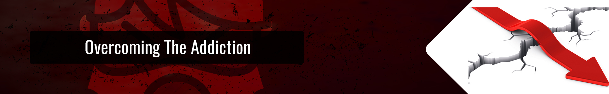
Identification:
Just like any other addition, the way to begin treatment is to identify it, and the best way to do that is by keeping notes. I always carry a notebook in my pocket, for a number of reasons, so it's easy for me to scribble down random thoughts throughout the day, but also to track things that are bothering me in day-to-day life.

Grab a notebook and a pen and keep them on you. Every time a stressful situation pops up, take out the notebook and jot down a brief description of what happened, and how you are responding to it. Is your anger building? Do you feel a need to smoke, drink, paint, etc? Can you feel your anger beginning to take hold? The notebook can become a habit in its own right, and a positive one. So without doing anything, you are already one step closer to the next thing I'm going to talk about.

Substitution:
Remember, that any addiction is a result of habits formed by repetition. Whether that is drinking coffee(my preferred way to yank myself out of writer's block), scribbling your thoughts in a notebook, or finding some other activity you can do that will bleed off the stress in a positive way.

When I was in college, I experimented with an ancient technique to maintain mental focus. I would wear a rubber band around my wrist, and every time my mind would wander to a place I didn't want it to go, I would snap the rubber band. I don't recommend that as an anger cure, but jewelry can be a reminder to calm down and bleed off stress before it comes to a head. You could wear a rosary, or other beaded jewelry, and take a couple minutes to concentrate on breathing slow and relaxed, counting each breath by passing a bead over your finger until you reach the end of the strand. You can twirl a wedding band in the same fashion, while focusing on positive things or relaxed breathing.

Talk to someone. If you are lucky enough to have an understanding friend or family member. Give them a call and vent. Offer to be a listener for them in return, and when they call, just listen. You don't have to give advice, or be some kind of expert psychologist. Just having someone to listen to you can make you feel better. I believe this is why social media has become so potent. It has become an easy way to shout at the rain when you need to, though I can't recommend broadcasting your negative energy to the web, because you will get unwanted feedback, which could cause more withdrawal. See? Social media can be addicting for the same reason.

Practice a mantra. Once you feel the stress building, before you even get angry, launch a pre-emptive strike by telling yourself, “I won't be a slave to anger.” Count to ten or twenty. Stop in your tracks and watch a tree or some traffic and feel the wind on your face. If someone is stressing you out, say to yourself, “Just let them have this, it isn't that important.” They can be right this time, or they can win, or whatever.

View the argument from above, or from a 3rd person perspective.

Try to envision the argument as being petty or silly (because we all know that most of the arguments that really get to us are in the long run anyway).

Ask yourself if anyone is going to care years in the future when you are on your deathbed. Ask how the argument is important to attaining your goals.
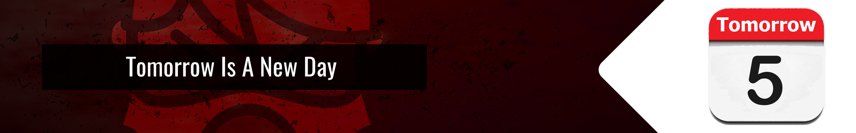
Anger is a problem. Addiction is a problem. And when you combine them you can put yourself in a precarious spiral quickly. But there's no reason to feel trapped. People have been struggling with anger since the beginning of civilization. It's nothing new, and it's nothing that can't be overcome.

Hopefully this article was helpful as a start, but if you want to know more, there are thousands of books out there written on the topic that can give you more perspectives, more ideas, and more suggestions for dealing with it. Anger can be overcome, a little at a time, but you also have to realize that, like any addiction, it's a fight that you need to fight everyday. If you have a little relapse, don't feel like a failure. Just try to calm down and focus again on the things you need to do in order to put yourself back on track. Carry your notebook, practice your mantras, and try to make the most of every day. Remind yourself in the morning of what you need to do when stress hits, and have a plan for dealing with it.

And remember to smile. Force it if you have to. The endorphins released will fight to suppress the anger hormones and keep them from bubbling to the surface.

